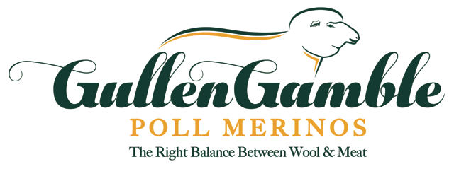

**Mark & Kym Kerin**

M: 0427 464 252 E: [gullen@bordernet.com.au](mailto:gullen@bordernet.com.au)

**Dan Veer**

M: 0439 851 970 E: [theveers@outlook.com](mailto:theveers@outlook.com)

“GullenGamble”, 309 GullenGamble Road, Yeoval NSW 2868 [www.gullengamblemerinos.com.au](http://www.gullengamblemerinos.com.au)

**ANNUAL RAM SALE**

**Tuesday 17th September 2019**

**Ram Display & Sale - Inspections from 10am – Sale @ 1pm**

**Versatility and Flexibility- THE BREED YOU NEED!**

You can find us at the follow events, plus on-property inspections are always welcome:

* **Midstate Merino Field Day, Dubbo** – 18th June
* **Nyngan Ag Expo** – 3rd August
* **Bathurst Ram Expo** – 10th August

**Open Day @ GullenGamble**

**Sunday 8th Sept from 10am**

**Guest Speakers**

* **National Merino Sheep Show, Dubbo** – 27th & 28th August
* **South West Slopes Field Day**, **Harden** – 3rd September

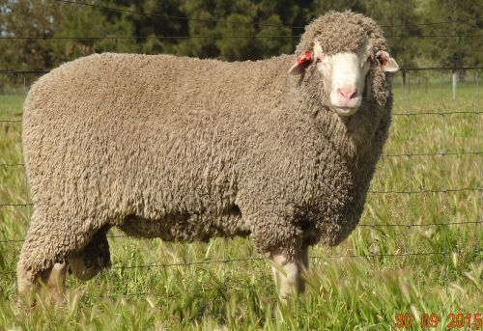

Image result for facebook image

**Information & Open Day @ GullenGamble**

**Date to be advised**

Guest Speakers

Lunch provided