Billa Burra Burra
Poll Merino
Big – Early Maturing – Soft – Deep Crimped Wools
Annual on property ram sale
1087 Black Range Road Yass
Friday 6th October 2023 at 1pm
Pre-sale inspection day Saturday 23th September
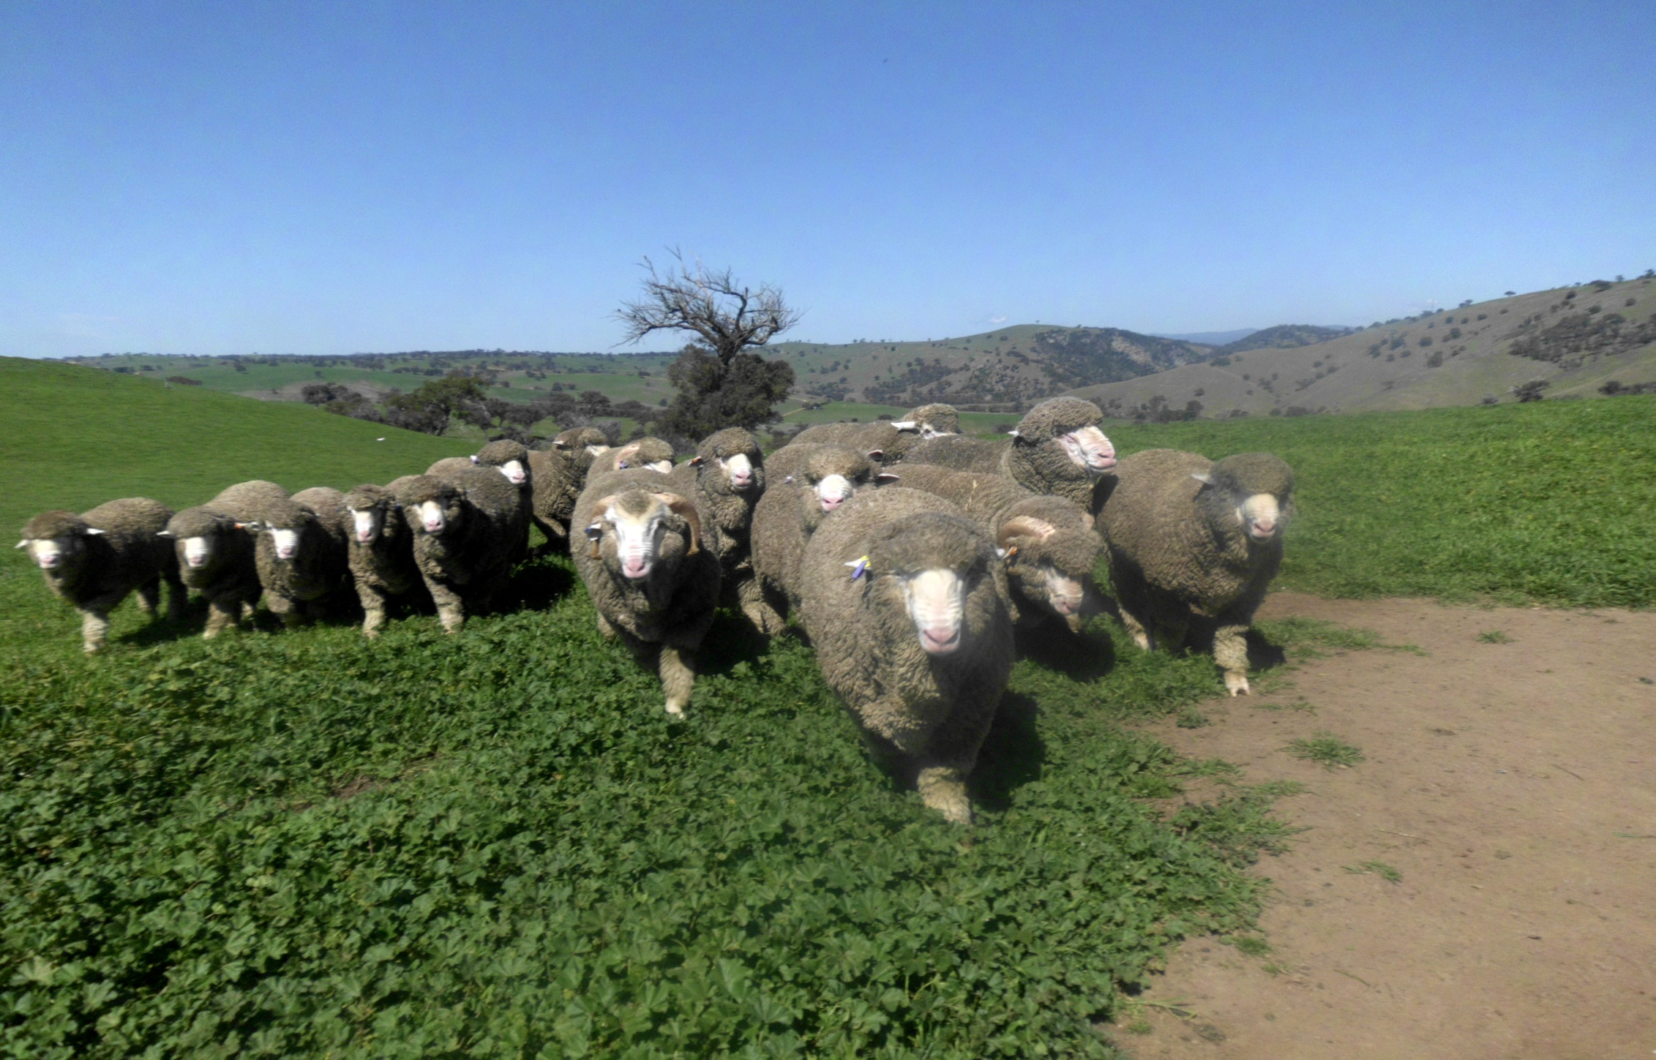

100 1YO rams
5 year clip average 18 micron
Ram Sale photo catalogue on our website from mid-September www.billaburraburra.com
Contact: Keith McGrath - 0428625658

